Computer Language Coding Concepts

New & Annul
The principles new and annul add the following members to the system objects related item and related list item:

New
Annul
Created . Get
Created . Set

The New command creates a new object and assigns a reference to it to the related item or related list item.

The Annul command makes the related item or related list item not refer to any object anymore, and releases its reference from the originally referred target.

The procedures of these system members can be extended with extra functionality, as explained in the section Extending the System Interface.

The system members New, Anull, Created . Get and Created . Set are part of the system interface of a related item or a related list item and displayed in a diagram as follows:

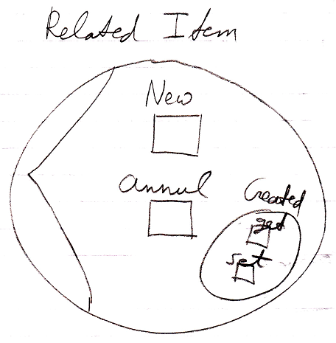

See also: System Objects, Related Item, Related List Item, Extending the System Interface

Author & Copyright: Jan-Joost van Zon Date: June 23, 2009 – July 24, 2008 Location: Oosterhout, The Netherlands Status: Finished

Ideas

The texts below are loose ideas, yet to be turned into good documentation.

Objects & Classes,
2008-08-17

> ‘Object annulment’
Consider what happens when an object is annulled, that others have references to. In that case the object is not destroyed, but the last referrer in the redirections will from then on represent the object itself.
> ‘Class annulment’
Consider what happens if a class is annulled, but an object is not.
In that case, the objects that have that class will not be destroyed. They will become classless, and will start representing their own class, and they can be filled with arbitrary contents again.
> ‘Class class annulment’
Consider what happens if a class’s class is annulled.
In that case a class will define its own contents again, not based on another class’s contents.

JJ

Annul,
2009-06-17

Actually, it usually does not work that way. When you annul one object reference, that was supposed to represent the target object, another imaginary object reference just comes in its place, connecting all the other references, in accordance with the rules of automatic containment.

It is different when you annul an object reference, that other object references point to: so pointers to a reference. This actually does annul the object of the reference, thus annuls the target object of the pointers to the reference.

So none of the situations presented in the previous idea will ever occur. Target classes and target objects are imaginary in automatic containment. Even if you could delete them, an imaginary one will pop up again straight away.

Oh, I have not considered class annulment… it may still count for class anullment.

JJ

